DEVELOPMENT OF SIGNAL LIGHTS VEST FOR

CYCLISTS USING VOICE

COMMAND

CHAPTER II

REVIEW OF RELATED LITERATURE AND RELATED STUDIES

Arjay T. Añoso

Arjay S. Beligañio

John Rafael H. Brigildo

November 11, 2023

**Chapter II**

**REVIEW OF RELATED LITERATURE AND RELATED STUDIES**

This chapter reviews the related literature and studies of different published books and researches, as well as internet sources, to provide a comprehensive understanding of this study. Furthermore, the gathered information will serve as the basis for the conceptual framework.

The literature review is an essential component of any research study. It allows researchers to develop a deep understanding of the topic of interest, to identify gaps in the literature, and to situate their study within the broader context of existing knowledge. By conducting a thorough literature review, researchers can ensure that their study is well-informed and that it makes a significant contribution to the field. (Martell, 2019, p. 1).

The review of related literature and study serves several important purposes. First, it helps the researcher to develop a deep understanding of the research topic. Second, it helps the researcher to identify any gaps in the existing knowledge that their study can address. Third, it helps the researcher to develop a theoretical framework for their study. Fourth, it helps the researcher to position their study within the broader context of the field. This means that the researcher should not simply summarize the existing literature, but should also evaluate its strengths and weaknesses. The researcher should identify any areas where the existing literature is incomplete, contradictory, or outdated. The researcher should also identify any opportunities to extend or refine the existing knowledge. (Creswell, 2018).

**Arduino Nano**

The Arduino Nano is a small, complete, and breadboard-friendly microcontroller board based on the ATmega328. It offers the same connectivity and specs of the Arduino Uno board in a smaller form factor. The Arduino Nano has 14 digital input/output pins, 8 analog inputs, and a mini-B USB connection. It can be powered by a USB connection, an external power supply, or a battery. The Arduino Nano is a popular choice for small and wearable projects because of its small size and low cost. Figure 1 shows the Arduino Nano pinout.

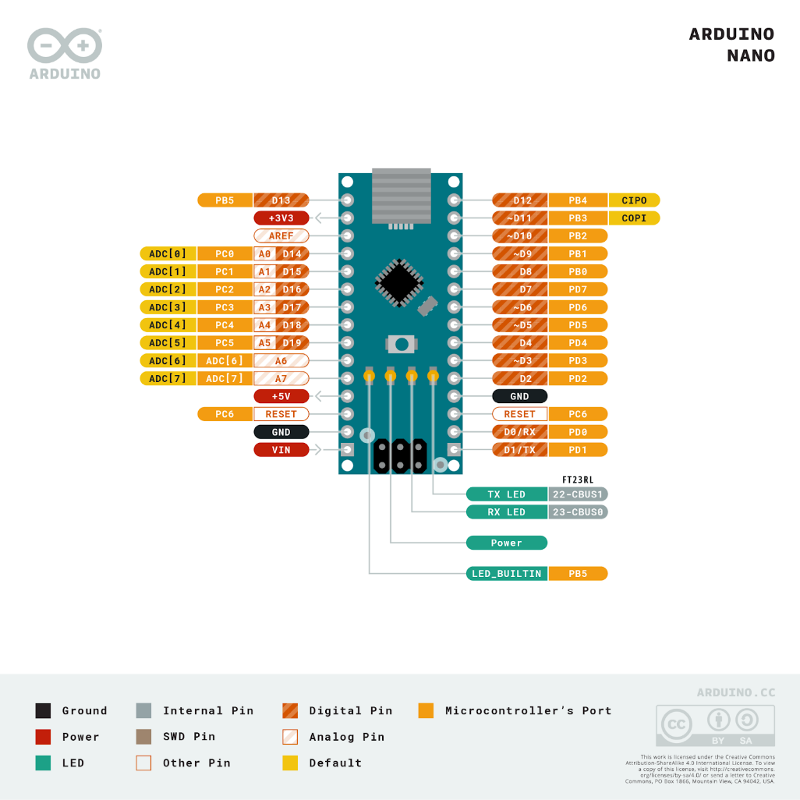

Fig. 1 Arduino Nano Pinout

**Voice Recognition Module**

It’s a compact and easy to use speech recognition board that can be interfaced easily with Arduino. Voice Recognition Module is a speaker dependent voice recognition module. It supports up to 80 voice commands in all. Max 7 voice commands could work at the same time. Any sound could be trained as a command. Users need to train the module first before letting it recognize any voice command. It has a variety of features, including UART/GPIO control, user-controlled general pin output, and a recognizer that holds the active voice commands. It also has a recognizer index, which corresponds to each voice command region. Users can train, load, and record voice commands, and each command has a signature and group. It can be used to control robots and other devices with your voice. For example, you could train the module to recognize the voice commands "forward", "backward", "left", and "right" to control the movement.

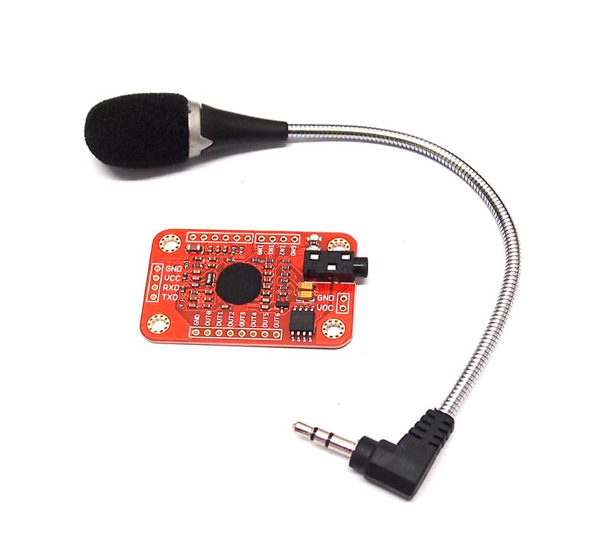

Fig. 2 Voice Recognition Module

**LED**

A light-emitting diode (LED) is a semiconductor device that emits light when an electric current is passed through it. LEDs are more energy-efficient and longer-lasting than traditional incandescent bulbs, and they are used in a wide variety of applications, including lighting, displays, and signage.

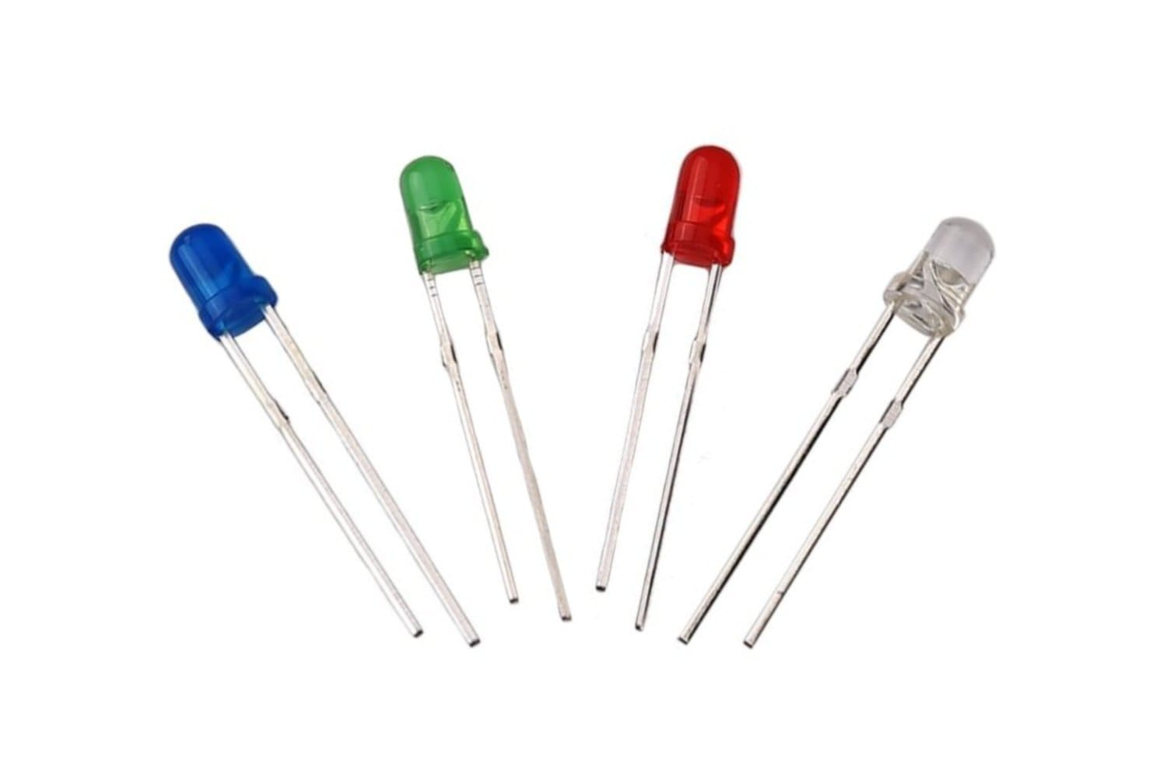

Fig. 3 LEDS

**Cyclist Vest**

A cyclist vest is a versatile and practical piece of cycling clothing that can help cyclists to stay warm and comfortable in cool or windy weather. It is typically made of a breathable fabric with a fitted design, and can be worn over a variety of other cycling clothing. Cyclist vests are also often available in reflective or fluorescent colors to help cyclists be seen by motorists in low-light conditions.

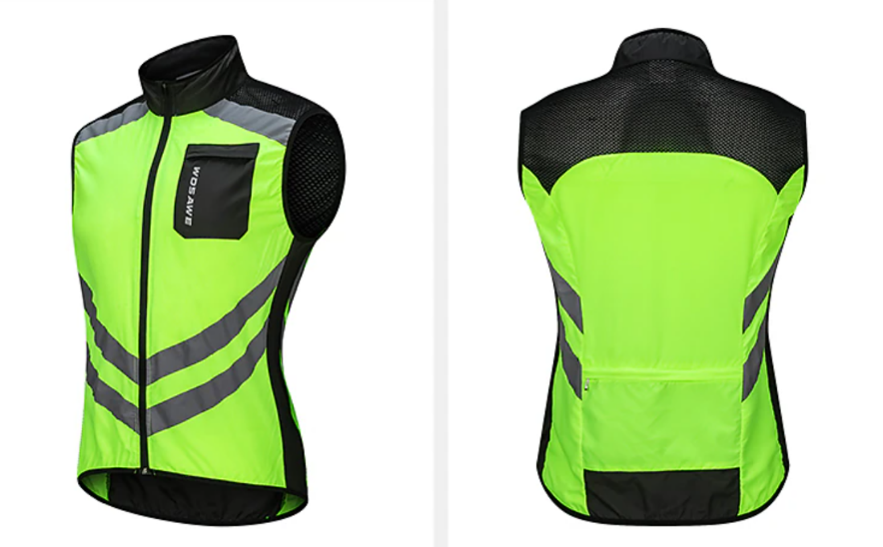

Fig.4 Cyclist Vest

**RELATED LITERATURE**

***VeloCity: Using Voice Assistants for Cyclist to Provide Traffic Reports***

G. Salvino et al. (2021) design, development, and evaluation of VeloCity, an application for reporting traffic incidents and structures relevant to cyclists. The authors compared three input methods (touch, in-app speech recognition, and the voice assistant of the operating system) and found that participants preferred to use the voice assistant as it was the least distracting. They also found that participants preferred short commands over conversational phrases. Based on their results, the authors presented five guidelines for designing voice user interfaces for cyclists.

Rangan et al. (2018), titled "Voice Controlled Smart Helmet," presents a comprehensive exploration of integrating voice control technology into motorcycle helmets. The system consists of a voice module to control the visor, turn indication, headlights, horn, and also the ignition system, the user is given much more options to control the vehicle rather than getting deviated from driving. Since the user uses voice controls to do the activities, he/she will stay awake throughout the ride.

Nordmark Anton (2019), stated that traffic is a complex environment in which many actors take part; several new technologies bring promises of reducing this complexity. However, cyclists—a particularly vulnerable road user group—have so far been somewhat put aside in these new developments, among them being *Cooperative Intelligent Traffic Systems* (C-ITS) and their aspects of human–computer interaction. This master’s thesis of industrial design engineering presents five multimodal collision warning signals for cyclists—future ones in these supposed C-ITS—using a novel application of bone conduction headphones (BCH) via sensations of both sound and touch. The thesis project was conducted as a complementary subset of the larger research project ‘V2Cyclist’ orchestrated by RISE Interactive. V2Cyclist set out to adapt the wireless V2X-protocol for cyclists by developing a physical prototype in the form of a bicycle helmet and corresponding human–computer interface.

***LifeLight: Wearable Active Hazard Detection System for Urban/Suburban Nighttime Cyclists***

N. Hinson et al. (2019) use Arduino microcontrollers, which, in conjunction with HC-05 Bluetooth modules, facilitated the communication necessary for the system's operation. The HC-05 modules were configured in a master-slave setup, allowing one module to transmit signals while the other received them. One Arduino was equipped with a LiDAR and a logic converter. The TF-mini LiDAR sensor has a range of 12 meters in ideal conditions, but in reality, it works well up to 10 meters in dusk and nighttime lighting conditions with less than 1% error. The LiDAR sensor works best when it is aimed at a surface that is at an angle of 60 degrees or less. To avoid detecting vehicles that are not a danger to the rider, the LiDAR is set to only detect vehicles that are directly behind the rider. The LiDAR has a very narrow beam, so it will not detect oncoming vehicles unless they are on a collision course with the rider. This system is to decrease the possibility of collision and visibility for cyclists and alerting them to vehicles approaching from behind.

***LED Bike Safety Vest***

FAHMIDDIN, A. W. Z. B. (2023) This study is intended to develop a safety vest for bikes using a gyroscope system. Wearable device that is designed to improve the visibility and safety of cyclists. The vest is equipped with a variety of LED lights that can be programmed to flash in different patterns, making the cyclist more visible to other road users. The LED in the vest automatically lights up depending on what the gyroscope system indicates, if you turn right the LED indicator shows your turning right and vice versa.

Maroma A. (2018) Development of Motorcycle Jacket with Modified Indicator and Brake Lights. The study dealt with the development of a motorcycle indicator and brake light system that is integrated into a standard riders jacket. The device was conceived for the purpose of increasing the visibility of the rider especially during night time. The system was developed in such a way that minimal modifications can be made to the lighting system of standard motorcycles in order to incorporate the device. The device was also fabricated by using materials that are readily available in the mainstream electronics market for ease of maintenance.

Fadzil, A., Jalaludin, N. A., & Sadun, A. S. (2022) suggested the blindspot detection system.  The system uses ultrasonic sensors to detect nearby obstacles in the cyclist's blind spot area. When an obstacle is detected within 10 meters, the system alerts the cyclist with an LED light. When an obstacle is detected within 2 meters, the system alerts the cyclist with a buzzer. This gives the cyclist more time to avoid a collision.

**RELATED STUDY**

Cycling may be a great way to get exercise and take in the environment, whether you're commuting to work or just having fun around the community. Riding on the road, however, is risky as you never know whether cyclists or pedestrians will be paying attention to your turn.

According to Dulo, J. et al (2022), the signal light would consist of an automatic voice turn and a manual switch that could be mounted on your bicycle. The system’s design is focused  on using voice recognition technology to activate signal lights on a vest worn by the cyclist, allowing them to make turns without having to raise their hands. The system is designed by using an Elechouse V3 module to train their voice recognition AI and created an AI with a Google Text-to-Speech library. They also used an Arduino Pro Mini/UNO. The collected data sets to assess whether or not the signal lights will turn on after the voice has been recognized. They concluded that a voice-activated signal light system for bicycles is a feasible and effective solution for improving cyclist safety on the road. They found that the system was able to accurately recognize voice commands and activate the signal lights in most cases. They also found that the system was easy to use and control, and that it could be a valuable tool for reducing the risk of accidents involving cyclists. However, they also noted that there were some limitations to the system, such as the need for clear and consistent voice commands and the potential for interference from background noise.

Voice-based direction indicator for the cycle was proposed by IJSHRE, (2022). A wearable device that is linked to an app, and a wireless control that eliminates the need to take your hands off the handlebar . The wearable device is a foam panel that snaps together and contains up to four LED signals: left, right, forward, and stop, to keep pedestrians informed at all times . The app is called Dabble and is designed to be easy to use . The purpose of the system is to assist bicycle riders in indicating their direction, as well as providing automatic headlight and horn . The wearable device is designed to keep pedestrians informed at all times, and the wireless control eliminates the need to take your hands off the handlebar. According to the study, they found that their solution is helpful for bike riders, but it still needs improvement in some parts . They tested the project on a bicycle and found that it provides automation, and the rider does not have to care about unnecessary things which can be automated . However, they also found that the horn automation part was a little annoying as it honks without the consent and sometimes it honks unnecessarily in traffic.

           Smart LED Bike Jacket proposed by Alsalman  et al. (2021), the study is about the development and evaluation of a Smart LED Bike Jacket (S.L.B.J). The purpose of the study is to implement a wearable jacket for cyclists that has different LED colors used for turning signals, provides physical alarms through vibration signals when objects are detected near the cyclist, and includes features such as night vision, a display screen, and a portable power bank charging mechanism. The study aims to enhance cyclist safety on the road and reduce the risk of accidents. They also found that the system was easy to use and control, and that it could be a valuable tool for reducing the risk of accidents involving cyclists. However, they also noted that there were some limitations to the system, such as the need for longer life span of the power source for the reason of some high power consumption of LEDs they used in the system.

         According to Harshith H., Dr. M L Anitha (2020), highlighting the  potential of development and implementation of the Smart Cyclist Jacket  to address the challenges faced by cyclists in urban environments. The jacket's innovative design, coupled with the integration of technology such as LED indicators and voice command functionality, aims to improve the cycling experience and reduce the risk of traffic accidents. The Smart Cyclist Jacket, features LED indicators for left, right, and stop signals, which can be controlled through voice commands via the accompanying Android application. The purpose of these features is to enhance the visibility and safety of cyclists, particularly during night time, by providing a hands-free method of signaling and navigation. They found the potential benefits of implementing the Smart Cyclist Jacket, including the reduction of traffic accidents in major cities and the promotion of cycling as a mode of transportation. The authors suggest that the jacket's innovative design and safety features may attract more people to cycling and improve overall safety for cyclists. Also, they found highlights the potential for regulations mandating the use of safety gear for cyclists, similar to the rules for motorbike and car users.

**Conceptual Framework**

This illustrates the conceptual framework that will guide the researchers on their study. It is divided into three sections.

|  |
| --- |
| **PROCESS** |
| A. Planning  B. Designing  C. Selection of materials to be used in the study.  D. Circuit Construction  E. Programming  F. Assembling  G. Testing and evaluation of the whole system. |

|  |
| --- |
| **OUTPUT** |
| A detailed documentation of the Signal Lights Vest for Cyclist using Voice Command. |

|  |
| --- |
| **INPUT** |
| Research about details and information on existing devices or systems that will be beneficial in developing the proposed system.  A working knowledge in microcontroller and programming language to be used in the study. |

Fig. Research Paradigm of the Proposed Design of Signal Lights Vest for Cyclist using Voice Command.

The development of the Signal Lights Vest for Cyclists using Voice Command begins with the input section, where researchers conduct studies on existing devices and utilize their knowledge in microcontroller and programming. The process involves planning, design, material selection, circuit construction, programming, assembly, testing and evaluation of the whole system, with every step contributing to the creation of the system. The output section shows the finished product, the Signal Lights Vest for Cyclists, including a prototype and detailed documentation of the study.

**Hypothesis**

The study tested the following null hypothesis:

The Signal Light Vest was able to generate a signal light system based on the cyclist voice command. The system accepts three types of signal lights, such as turn signal lights, brake lights and slow down lights.

**Table 1. Synthesis Table of the Related Literatures and Studies and the Researcher's Statement**

|  |  |  |
| --- | --- | --- |
| Theme of the Study | Author, Year & Title | Related Statements |
| Design, development, and evaluation of a voice user interface for cyclists | G. Salvino et al. (2021), *VeloCity: Using Voice Assistants for Cyclists to Provide Traffic Reports* | The authors developed a voice user interface for cyclists called VeloCity. They found that cyclists prefer to use the voice assistant of the operating system as it is the least distracting. They also prefer short commands over conversational phrases. |
| Integration of voice control technology into motorcycle helmets | Rangan et al. (2018), *Voice Controlled Smart Helmet* | The voice-controlled smart helmet system allows riders to control their motorcycle's visor, turn signals, headlights, horn, and ignition with voice commands. This reduces distractions and helps riders stay focused on the road. |
| Development of a Wearable Active Hazard Detection System for Cyclists | N. Hinson et al. (2019), *LifeLight: Wearable Active Hazard Detection System for Urban/Suburban Nighttime Cyclists* | The LifeLight system uses a LiDAR sensor to detect vehicles approaching from behind and alerts cyclists with a signal to their smartphone. It has the potential to reduce the possibility of collisions and improve cyclist safety. |
| Development of a safety vest for bikes using a gyroscope system | FAHMIDDIN, A. W. Z. B. (2023), *LED Bike Safety Vest Using Gyroscope System* | The study aims to develop a wearable device that is designed to improve the visibility and safety of cyclists. The vest is equipped with a variety of LED lights that can be programmed to flash in different patterns, making the cyclist more visible to other road users. The LED in the vest automatically lights up depending on what the gyroscope system indicates, if you turn right the LED indicator shows your turning right and vice versa. |
| Development of a motorcycle indicator and brake light system integrated into a standard rider's jacket | Maroma A. (2018), *Development of Motorcycle Jacket with Modified Indicator and Brake Lights* | The study aimed to develop a motorcycle indicator and brake light system that is integrated into a standard rider's jacket to increase the rider's visibility, especially at night. The system was designed to minimize modifications to the standard motorcycle lighting system and to use readily available materials for ease of maintenance. |
| Development of a blind spot detection system for cyclists using ultrasonic sensors | Fadzil, A., Jalaludin, N. A., & Sadun, A. S. (2022), *Blind Spot Detection System for Cyclists* | The system uses ultrasonic sensors to detect nearby obstacles in the cyclist's blind spot area. When an obstacle is detected within 10 meters, the system alerts the cyclist with an LED light. When an obstacle is detected within 2 meters, the system alerts the cyclist with a buzzer. |
| Signal Lights for Cyclist using Voice and Manual Switch | Dulo, J. et al (2022), *Signal Lights for Cyclist Through Voice Turn and Manual Switch* | Due to the COVID-19 pandemic, many people have switched to a much safer and healthier way of transportation, which is riding a bike or cycling. However, cyclists face the risk of accidents due to the lack of proper signaling when making turns. The study aims to introduce a solution to this problem by developing a product that utilizes voice recognition and manual switch activated bicycle turn signals. |
| Voice-based direction indicator for cycle | IJSHRE, (2022), *Voice-based direction indicator for cycle* | A voice-based direction indicator system for bicycles was proposed by IJSHRE (2022). The system consists of a wearable device with LED signals and a wireless control. It provides automatic headlight and horn, but the horn automation part needs improvement. |
| Development and evaluation of a Smart LED Bike Jacket (S.L.B.J) | Alsalman et al. (2021), *Smart LED Bike Jacket (S.L.B.J)* | A wearable Smart LED Bike Jacket (S.L.B.J) was developed to enhance cyclist safety by providing turning signals, physical alarms, night vision, and a display screen. The system was easy to use and control, but had high power consumption. |
| Development and implementation of the Smart Cyclist Jacket | Harshith H., Dr. M L Anitha (2020)*, iSmart Cyclist Jacket* | The Smart Cyclist Jacket is a wearable device that uses LED indicators and voice commands to improve the safety and convenience of cycling in urban environments. It has the potential to reduce traffic accidents and promote cycling as a mode of transportation. |